* Cognitive Psychology:

Cognitive psychology is a part of psychology. Which focus on internal mental processes like how man process information typically. It focuses all of the things that move on interior your brain, including attention, memory, thinking, perception, language, reading, listening and learning.

References: <https://www.verywellmind.com/cognitive-psychology-4157181>

* Cognitive Process:

What is a cognitive process?

There are numerous distinctive sorts of cognition, such as thinking, recalling, learning, wandering off in fantasy land, decision making, seeing, reading, writing, and talking. (pdf book) Cognition has too been depicted in terms of particular sorts of forms. These include:

* Attention
* Perception
* Memory
* Learning
* Reading
* Speaking
* Listening



Figure: Cognition Process

1. **Attention:**

What is attention?

In cognitive Psychology attention is the process that allows human to concentrate on an activity. It helps us to process it later more thoroughly. Attention is a crucial cognitive function and it helps with development of daily situations, and it is utilized in the larger part of errands that we carry-out day-to-day.

References: <https://www.cognifit.com/cognition>

<http://www.happy-neuron.com/brain-and-training/attention>

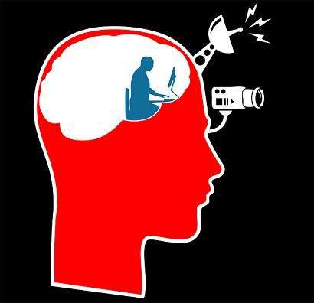

Figure: Human Attention

References: <https://www.lifepersona.com/cognition-processes-characteristics-and-structure>

How it work?

Consider attention as a highlighter. As you examined through an area of content in a book, Stands out that highlighted area, causing your attention focus in that section.

But the thought is not reasonable around centering your focus on one specific thing; it moreover includes overlooking an incredible bargain of competing for data and jolts. Attention permits you to "tune out" data, sensations, and recognitions that are not pertinent at the minute and instep centers your vitality on the data that's important. ​

References: <https://www.verywellmind.com/what-is-attention-2795009>

The capacity to concentrate and pay attention is a basic expertise in the cognitive working with individuals. In the event that consideration is not satisfactorily centered, the take-up of data tends to be frail and it is complex that it is put away in the brain structures.

References: <https://www.lifepersona.com/cognition-processes-characteristics-and-structure>

Key Points of attention:

In order to get it how attention works and how it influences your recognition and encounter of the world, it's fundamental to keep in mind a few vital focuses approximately how attention works

**Attention is limited:**

There has been a colossal sum of inquire about looking at precisely how numerous things we can go to and for how long. Investigators have found that key components that affect our capacity to remain on errand incorporate how interested we are in the boost and how numerous distractors we encounter. Considers have illustrated that consideration is restricted in terms of both capacity and term. The dream that attention is boundless has driven numerous individuals to hone multitasking. It's as it were in later a long time that investigate has pointed out how multitasking at times works well since our attention is limited.



Figure: Can't focus on both of the laptop and phone at a time because of attention is limited.

References: <https://news.rambler.ru/internet/36582431-sayty-znakomstv-kak-raspoznat-moshennikov-i-obezopasit-sebya/>

**Attention is selective:**

We have to be specific/ particular around what we choose to center on because of attention is limited asset. Not as it were must we focus on a particular thing in our environment. We have to be selective to find out what we go to, a prepare that frequently happens so rapidly that we don't indeed take note that we have disregarded certain boosts in favor of others.

References: <https://www.verywellmind.com/what-is-attention-2795009>



Figure: Selective attention permits your brain to filter out sound-related information in order to focus on other sounds, like discussions

References: <http://uxmag.com/articles/selective-attention-and-user-experience>

Attention is a fundamental component of our science, display indeed at birth. Our arranging reflexes offer assistance us decide which occasions in our environment require to be attended to, a handle that helps in our capacity to outlive.

References: <https://www.verywellmind.com/what-is-attention-2795009>

Role in Interaction Design

Interactive systems are customarily worked with undivided attention. In the interaction design the clients could influence by the attention on a few strategies.

**General guidelines:**

* Designers ought to endeavor to reflect the dialect and concepts clients would discover in the real world based on who their target clients are.
* Offer clients a computerized space where in reverse steps are conceivable, counting fixing and re-trying past activities.
* Interface creators ought to guarantee that both the realistic components and terminology are kept up over comparable platforms.
* At whatever point conceivable, plan frameworks so that potential mistakes are kept to a minimum.
* The client interface must be straightforward and simple to utilize.
* Making the content straightforward, perfect and too clear.

References: <https://www.interaction-design.org/literature/article/user-interface-design-guidelines-10-rules-of-thumb>

**Mobile specific guideline:**

According to the scenario, this smart thermostat mobile app will run on a smart phone or tablet for control thermostat which is at home or office. In this case-

* In this application I will try to hold the user’s attention on this application by showing relevant and necessary information.
* I will try to avoid showing huge information in a single interface, because of there is many smart phone has a small screen than average smart phone screen size.
* I will highlight important text and use multiple color in as it’s important.

**Memory:**

Memory includes recalling different kinds of information that permit us to act appropriately. It is exceptionally flexible, enabling us to do many tasks. (pdf book)

Memory is an important part of how we see our world. As a human beings, we have two types of memory those are short term and long term memory capacities. If we can understand how memory works and how we should work with that memory capacity then we can create perfect designs. This is critical for all architects, but especially so for data visualization architects who require to guarantee that their work is promptly caught on by the watcher in arrange for it to be instantly valuable.

References: <https://www.interactiondesign.org/literature/topics/human-memory>

It is not conceivable for us to keep in mind everything that we see, listen, taste, scent, or touch, because our brains would get totally over-burden. A filtering handle is utilized to choose what data gets advance prepared and memorized. This filtering handle, in any case, is not without its issues. Regularly we disregard things we would beyond a reasonable doubt adore to keep in mind and alternately remember things and we would adore to forget. For illustration, we may discover it troublesome to keep in mind regular things like friend’s phone numbers, or logical information such as numerical formulae. (pdf book)

**Short Term Memory:**

Short-term memory is an active or primary memory with a capacity for holding, but not controlling, a little amount of data in intellect, in a dynamic, promptly accessible state for a short period of time. To keep in mind a phone number that has fair been recited its an example of short- term memory. We can think short-term memory as computer RAM.

References: <https://en.wikipedia.org/wiki/Short-term_memory>

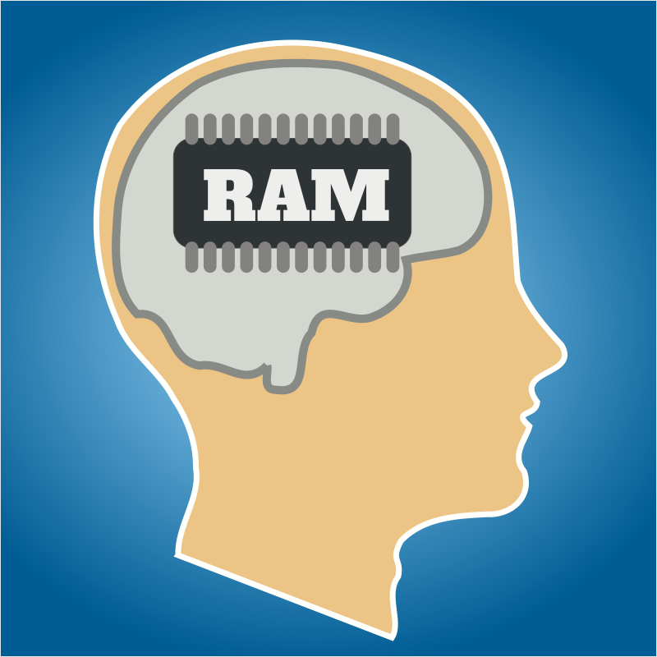

Figure:

References: <https://openclipart.org/detail/194608/working-memory>

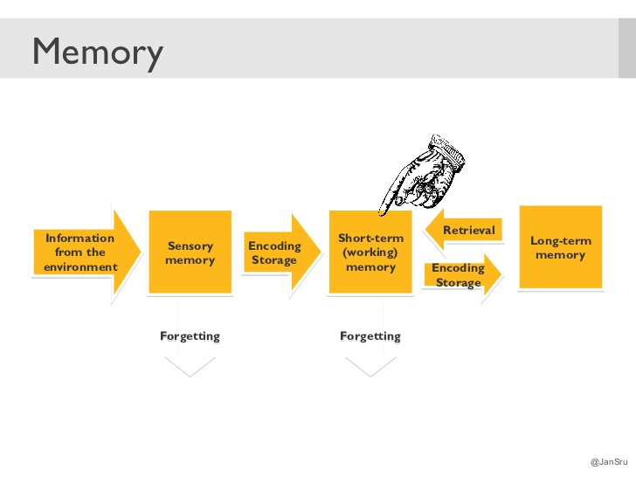

Figure:

References: <https://www.slideshare.net/JanSru/small-cognitive-psychology-for-big-interaction-design>

**Long-term Memory:**

The storage of information over an amplified period this is Long-term memory. In case you can keep in mind something which happened just few moments ago or decades earlier, at that point it's a long-term memory.

References: <https://www.verywellmind.com/what-is-long-term-memory-2795347>

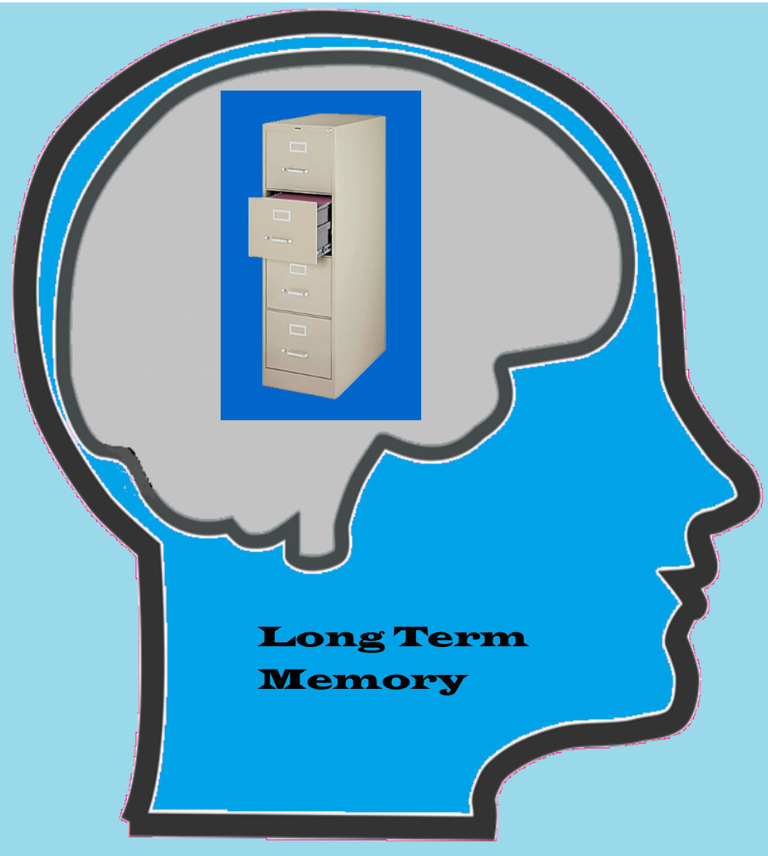

Figure: Long-term memory

References: <http://www.educational-evaluations.com/cognitive-process-long-term-memory/>

**General Guidelines:**

* To offer assistance clients to keep in mind and to supply different ways of data that is encoded
* UI creators ought to attempt to dodge cluttering of information
* All over the application should use consistent color, icon or animation. Unique icon use for representing a unique operation. Using same icon for multiple operation representation, then the user may be in confusion.

**Scenario specific guideline:**

* Current time and weather temperature should be visible in the application interface. There for user don't need to think about date or current weather.
* Selected options or settings should be more recognizable than recalling. In this application I will use different color for present settings, because users can easily recognize that is running settings.
* Cluttering of information ought to entirely avoid.
* All screens should be related to each other.

**Perception**